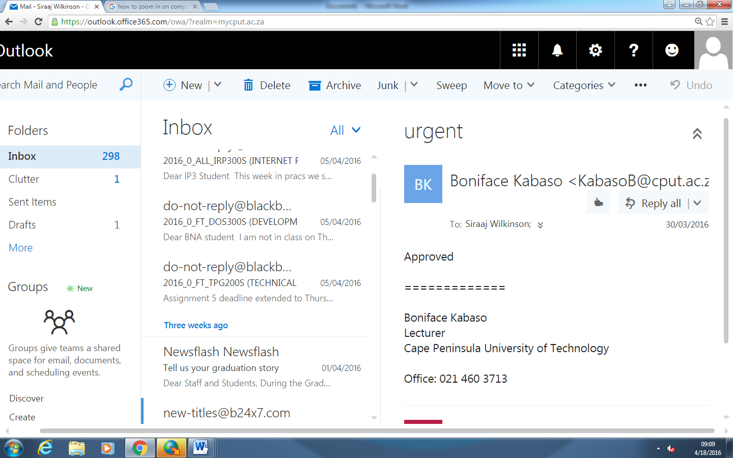

214068730

Siraaj Wilkinson

Domain approved